Create a project using the below details in the SEGW :
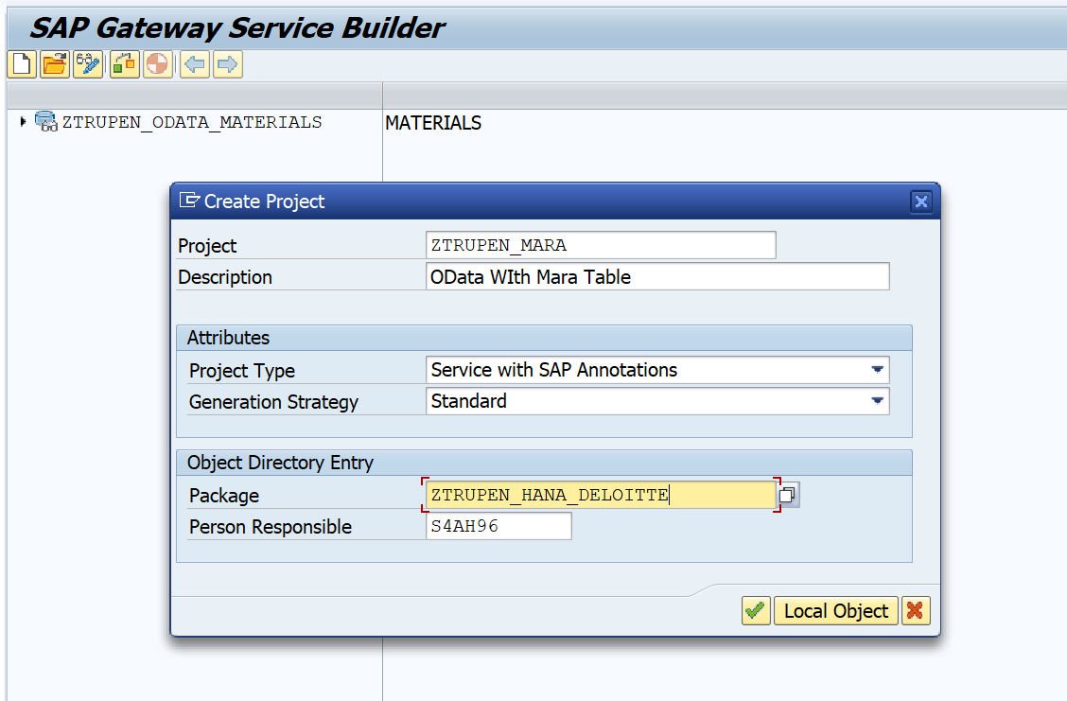
Below screen will appear where you can see below folder in project. In Folder data model, we can see three sub folders. Entity Type - it acts as work area , Entity Sets -It act as internal table and associations:
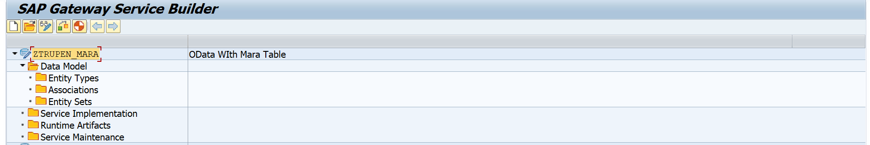

Now we are going to define structure of work area and internal table , Right click on Data model select import and select DDIC structure .
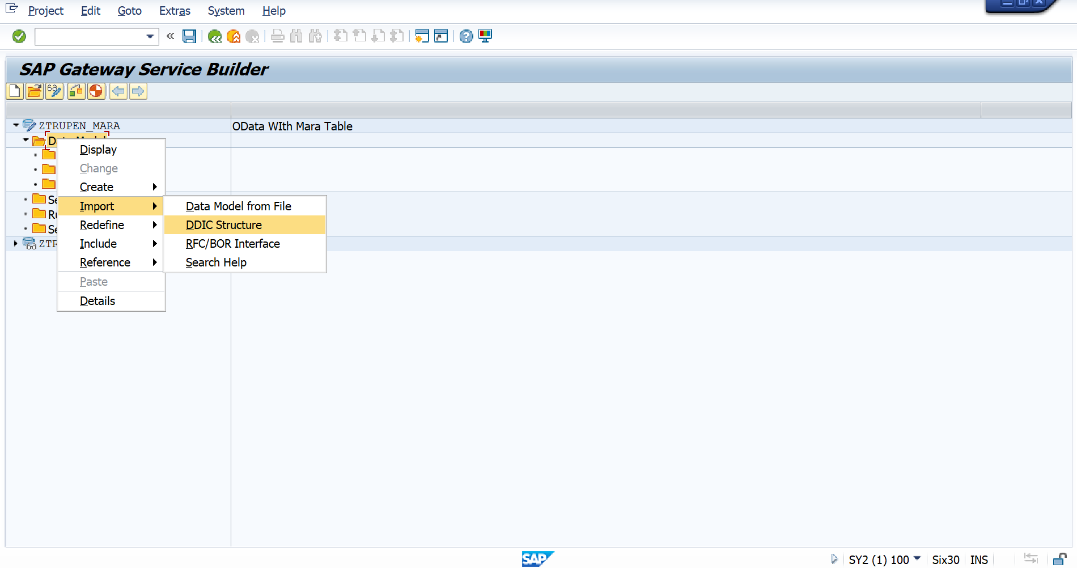
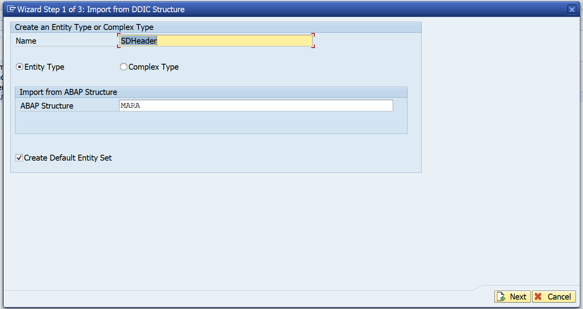
Now you will get the pop up screen with MARA table fields name. Select fields for your structure and click on next.
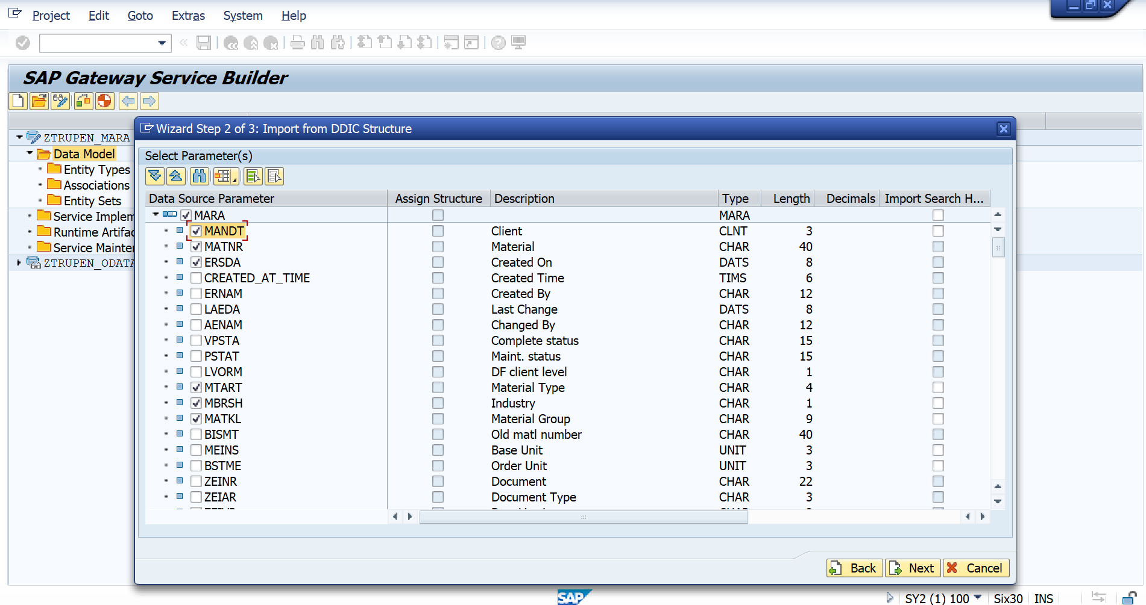
Other window will appear where we have to select the key field. tick on MANDT,MATNR as key fields and click on finish. You may get warning message , it can be totally ignored.
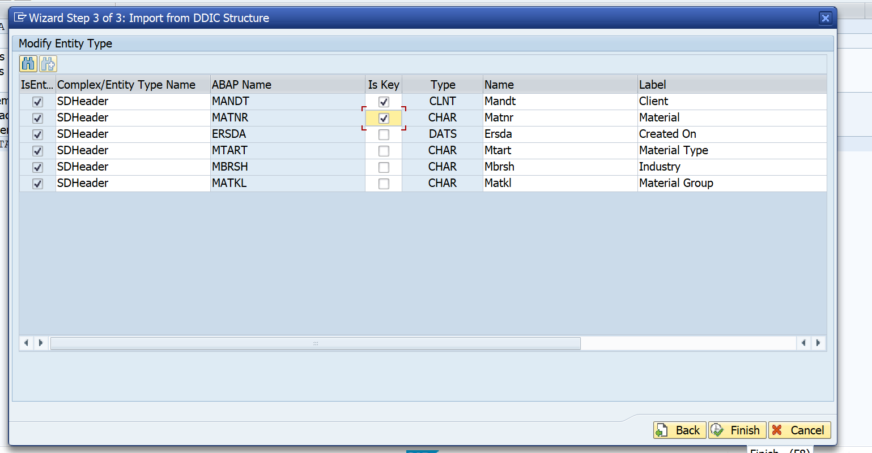

click on Save button at the top of menu bar
Now click on generate Icon, A pop up window will appear with class details , click on tick icon and proceed further. It will ask for package , give details and proceed further . These are also knowns as runtime artifacts.
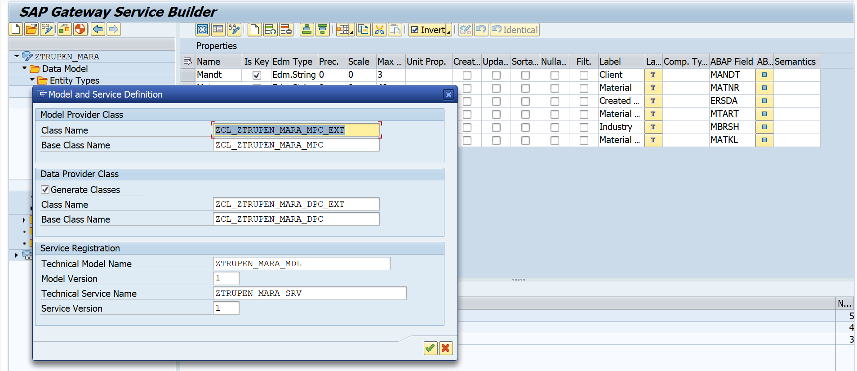
Step 2. Go to transaction code /IWFND/MAINT_SERVICE .
Click on push button Add services and add our service.
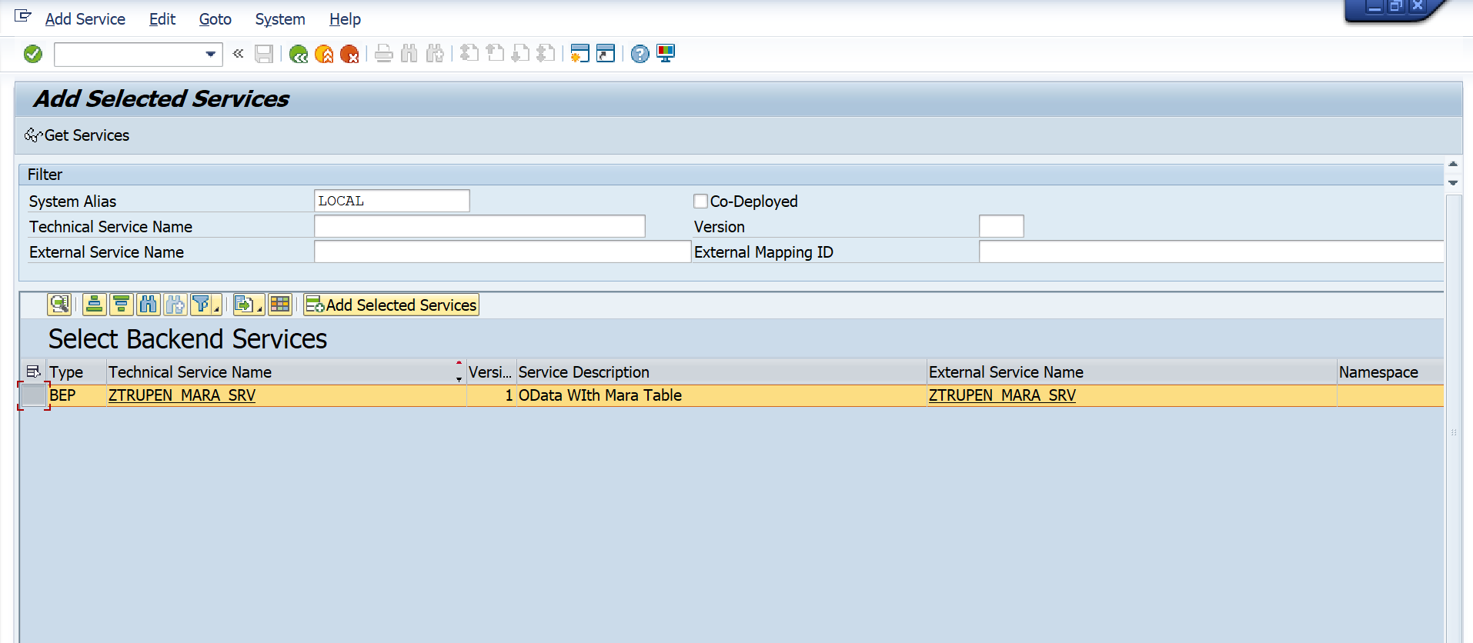

Now double click on your project name . A pop up window will appear , enter the package details and click on tick icon. An Information message will be shown where it will confirm about the service is created and metadata loaded successfully.
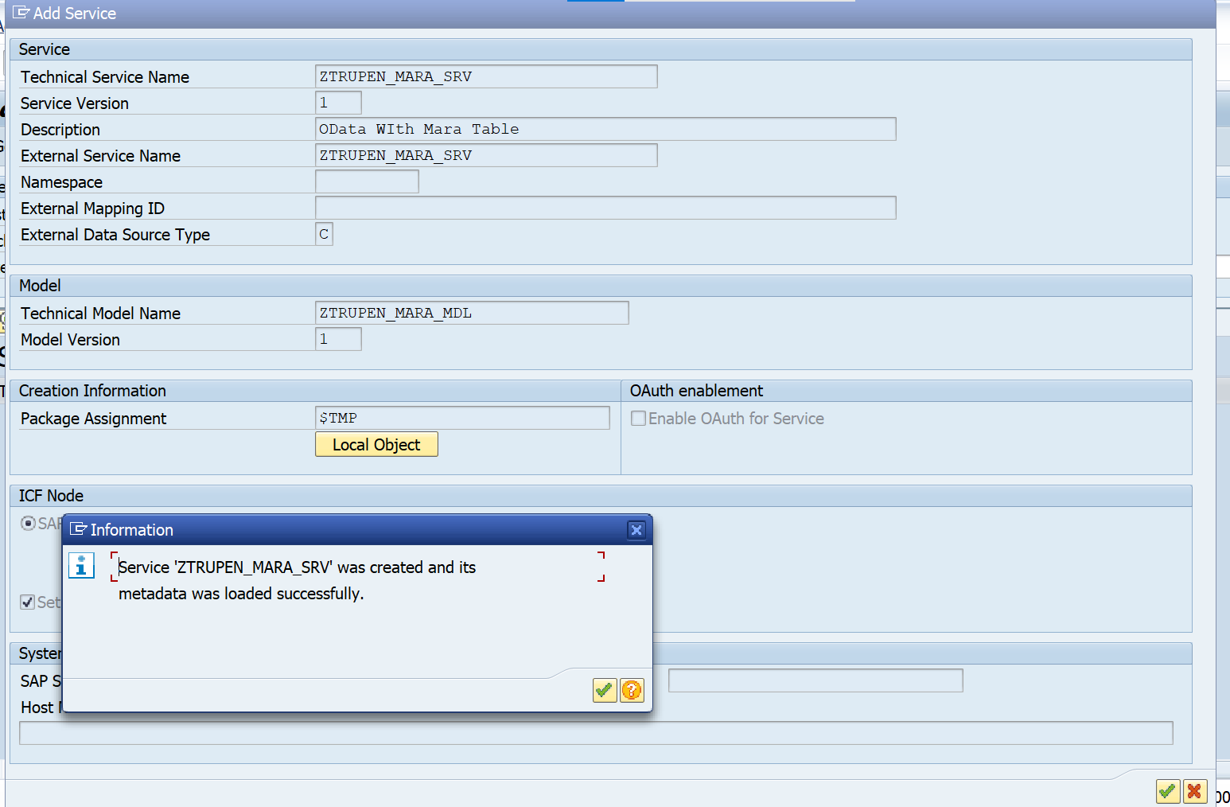

Now click back and go to main screen of transaction /IWFND/MAINT_SERVICE and find your service.
Click on SAP Gateway Client.
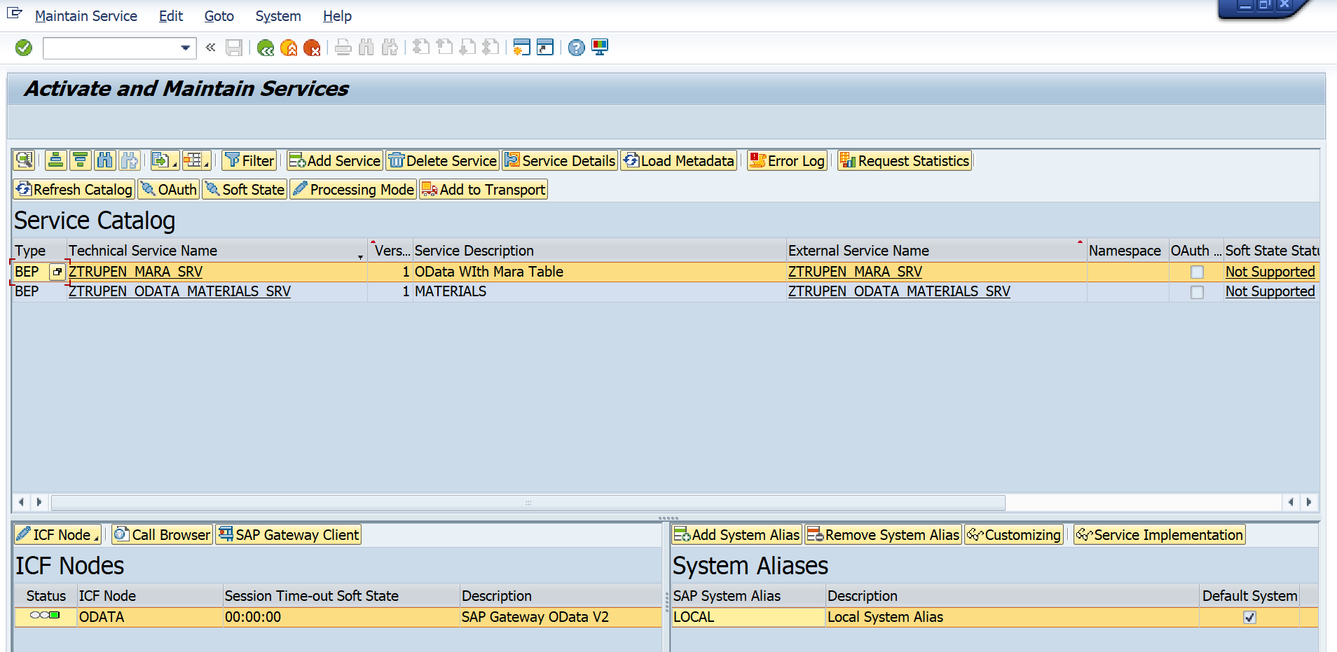
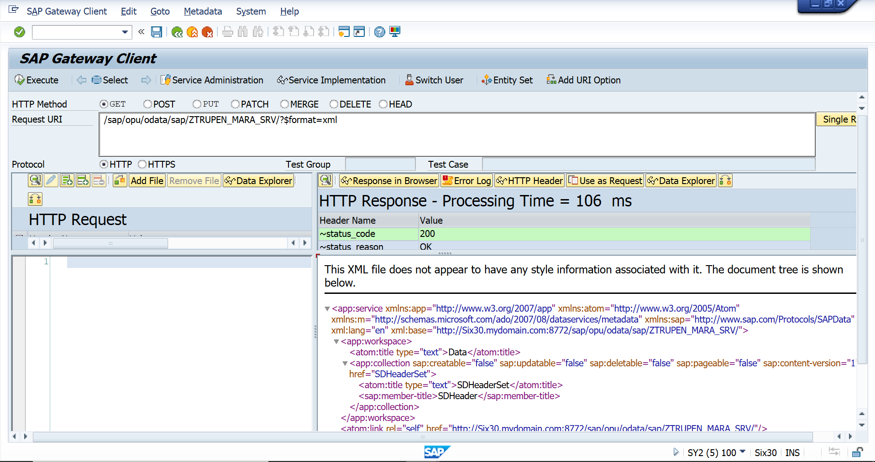

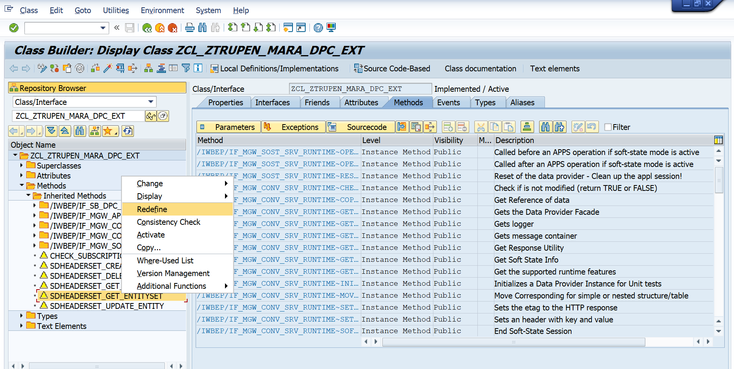
Write below code in method. Save and activate all related objects for classes.
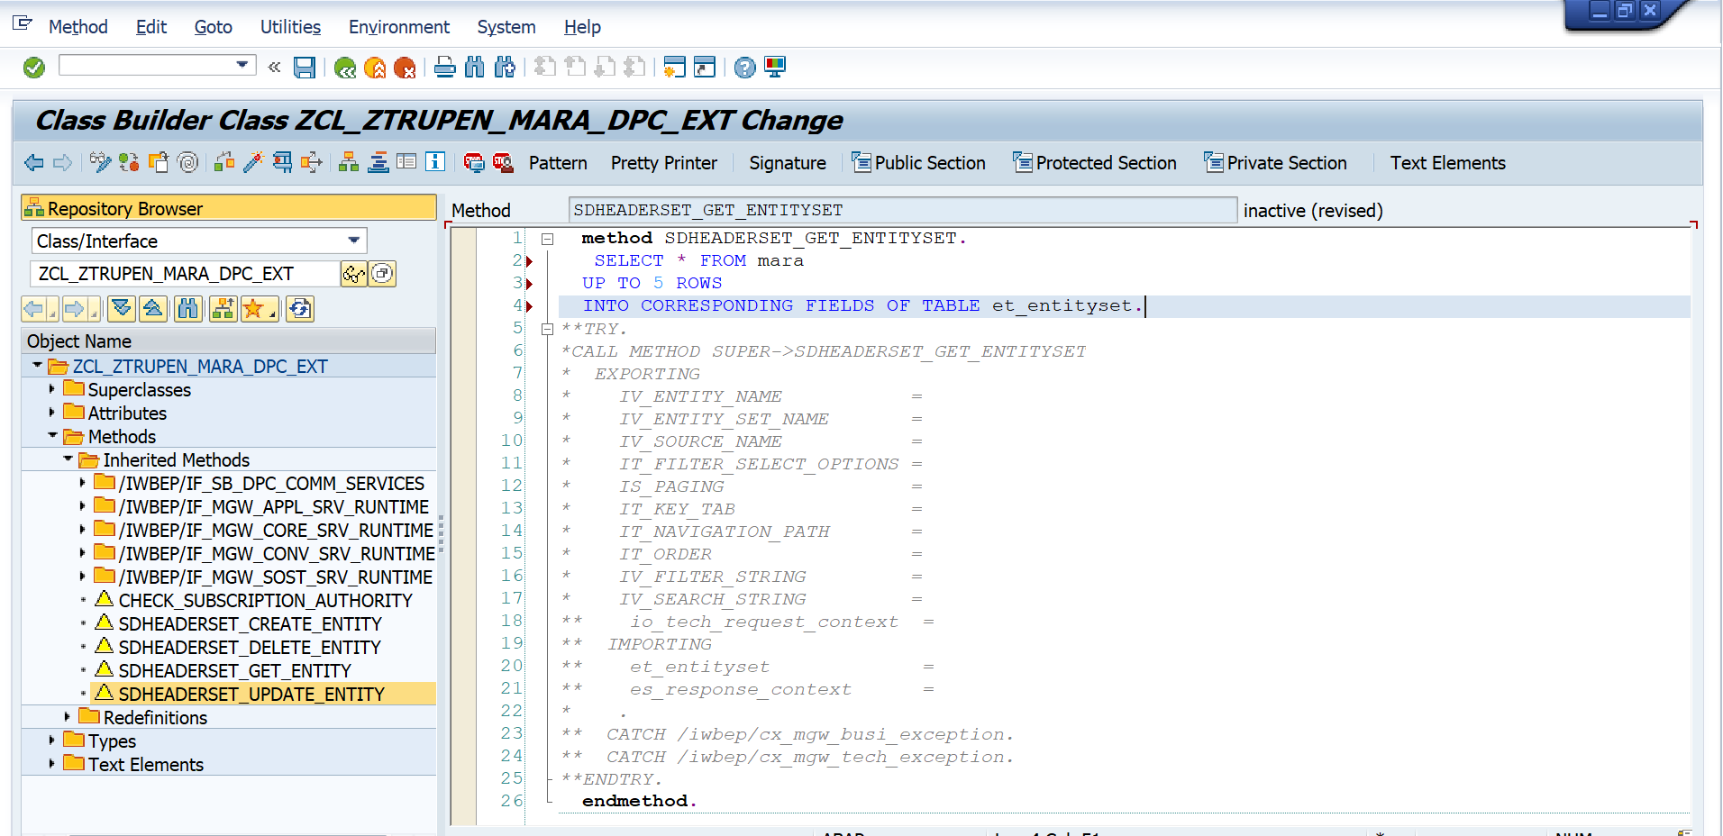
Do the same for delete entity:
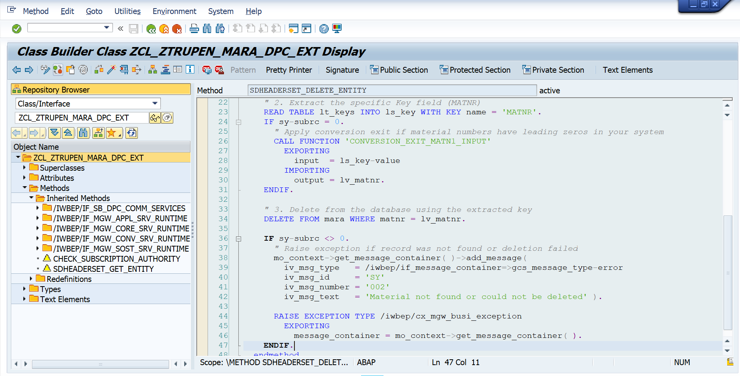
method SDHEADERSET_DELETE_ENTITY.
**TRY.
*CALL METHOD SUPER->SDHEADERSET_DELETE_ENTITY
* EXPORTING
* IV_ENTITY_NAME =
* IV_ENTITY_SET_NAME =
* IV_SOURCE_NAME =
* IT_KEY_TAB =
** io_tech_request_context =
* IT_NAVIGATION_PATH =
* .
** CATCH /iwbep/cx_mgw_busi_exception.
** CATCH /iwbep/cx_mgw_tech_exception.
**ENDTRY.
DATA: lv_matnr TYPE matnr,
lt_keys TYPE /iwbep/t_mgw_tech_pairs,
ls_key TYPE /iwbep/s_mgw_tech_pair.
" 1. Retrieve the keys passed in the OData URI
lt_keys = io_tech_request_context->get_keys( ).
" 2. Extract the specific Key field (MATNR)
READ TABLE lt_keys INTO ls_key WITH KEY name = 'MATNR'.
IF sy-subrc = 0.
" Apply conversion exit if material numbers have leading zeros in your system
CALL FUNCTION 'CONVERSION_EXIT_MATN1_INPUT'
EXPORTING
input = ls_key-value
IMPORTING
output = lv_matnr.
ENDIF.
" 3. Delete from the database using the extracted key
DELETE FROM mara WHERE matnr = lv_matnr.
IF sy-subrc <> 0.
" Raise exception if record was not found or deletion failed
mo_context->get_message_container( )->add_message(
iv_msg_type = /iwbep/if_message_container=>gcs_message_type-error
iv_msg_id = 'SY'
iv_msg_number = '002'
iv_msg_text = 'Material not found or could not be deleted' ).
RAISE EXCEPTION TYPE /iwbep/cx_mgw_busi_exception
EXPORTING
message_container = mo_context->get_message_container( ).
ENDIF.
endmethod.
For update and create as well in the respective classes:
method SDHEADERSET_CREATE_ENTITY.
**TRY.
*CALL METHOD SUPER->SDHEADERSET_CREATE_ENTITY
* EXPORTING
* IV_ENTITY_NAME =
* IV_ENTITY_SET_NAME =
* IV_SOURCE_NAME =
* IT_KEY_TAB =
** io_tech_request_context =
* IT_NAVIGATION_PATH =
** io_data_provider =
** IMPORTING
** er_entity =
* .
** CATCH /iwbep/cx_mgw_busi_exception.
** CATCH /iwbep/cx_mgw_tech_exception.
**ENDTRY.
DATA: ls_request_data TYPE zcl_ztrupen_mara_mpc=>ts_sdheader,
ls_mara TYPE mara.
" Read the incoming payload data from the request body
io_data_provider->read_entry_data( IMPORTING es_data = ls_request_data ).
" Map the request data to the standard table structure
MOVE-CORRESPONDING ls_request_data TO ls_mara.
" Insert into the database
INSERT mara FROM ls_mara.
IF sy-subrc = 0.
" Pass the successfully created data back to the response
er_entity = ls_request_data.
ELSE.
" Raise an exception if the creation fails
mo_context->get_message_container( )->add_message(
iv_msg_type = /iwbep/if_message_container=>gcs_message_type-error
iv_msg_id = 'SY'
iv_msg_number = '002'
iv_msg_text = 'Error while creating material' ).
RAISE EXCEPTION TYPE /iwbep/cx_mgw_busi_exception
EXPORTING
message_container = mo_context->get_message_container( ).
ENDIF.
endmethod.

method SDHEADERSET_UPDATE_ENTITY.
**TRY.
*CALL METHOD SUPER->SDHEADERSET_UPDATE_ENTITY
* EXPORTING
* IV_ENTITY_NAME =
* IV_ENTITY_SET_NAME =
* IV_SOURCE_NAME =
* IT_KEY_TAB =
** io_tech_request_context =
* IT_NAVIGATION_PATH =
** io_data_provider =
** IMPORTING
** er_entity =
* .
** CATCH /iwbep/cx_mgw_busi_exception.
** CATCH /iwbep/cx_mgw_tech_exception.
**ENDTRY.
DATA: ls_request_data TYPE zcl_ztrupen_mara_mpc=>ts_sdheader,
ls_mara TYPE mara.
" Read the incoming payload data
io_data_provider->read_entry_data( IMPORTING es_data = ls_request_data ).
" Map data to the database structure
MOVE-CORRESPONDING ls_request_data TO ls_mara.
" Update the database record
UPDATE mara FROM ls_mara.
IF sy-subrc = 0.
" Optionally return the updated entity
er_entity = ls_request_data.
ELSE.
" Raise exception if update fails
mo_context->get_message_container( )->add_message(
iv_msg_type = /iwbep/if_message_container=>gcs_message_type-error
iv_msg_id = 'SY'
iv_msg_number = '002'
iv_msg_text = 'Error while updating material' ).
RAISE EXCEPTION TYPE /iwbep/cx_mgw_busi_exception
EXPORTING
message_container = mo_context->get_message_container( ).
ENDIF.
endmethod.
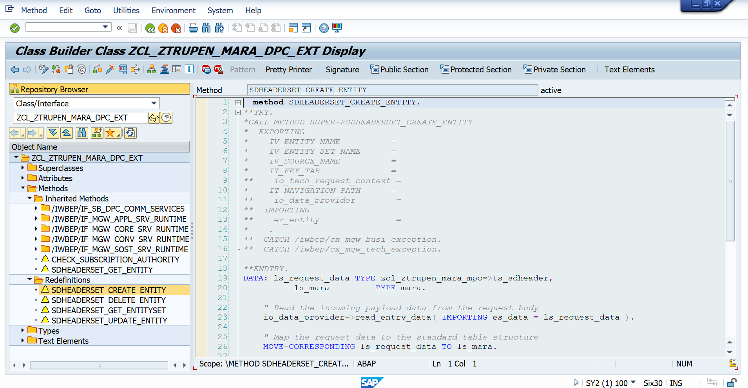

Get Method:
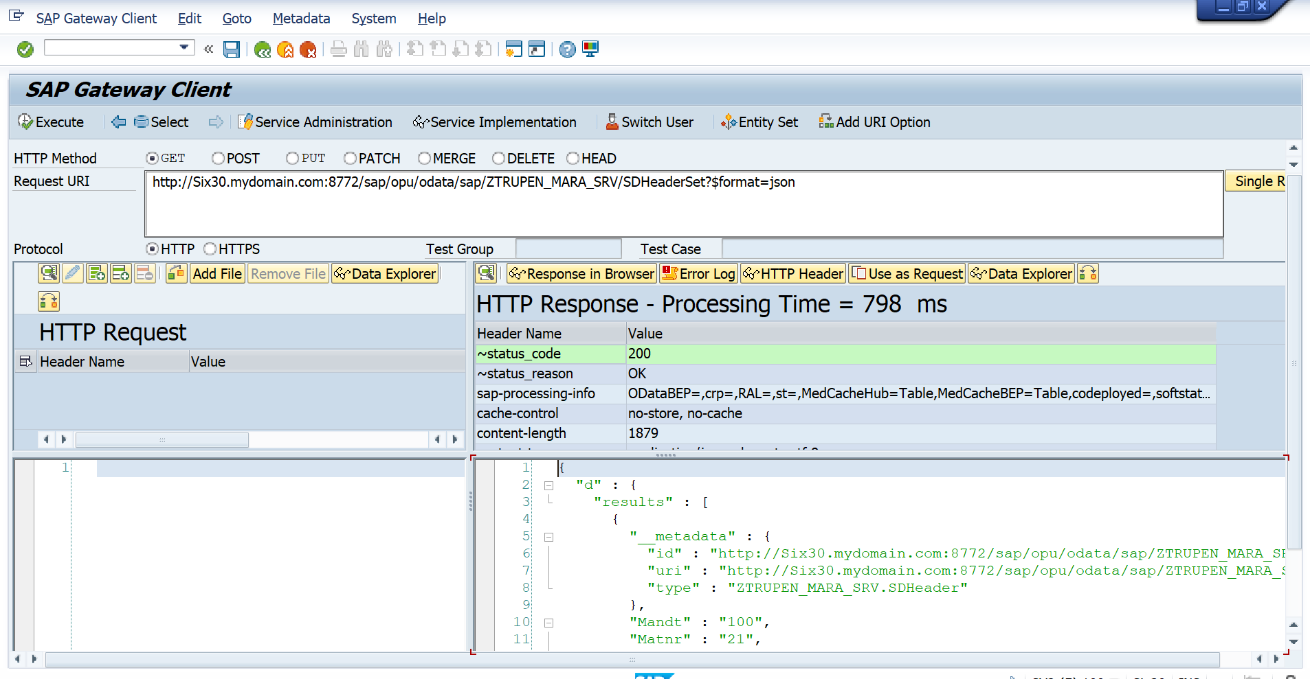
Post method:
http://Six30.mydomain.com:8772/sap/opu/odata/sap/ZTRUPEN_MARA_SRV/SDHeaderSet
{
"Mandt": "100",
"Matnr": "000000000000000009",
"Ersda": "2026-09-03T00:00:00",
"Mtart": "FERT",
"Mbrsh": "M",
"Matkl": "01"
}
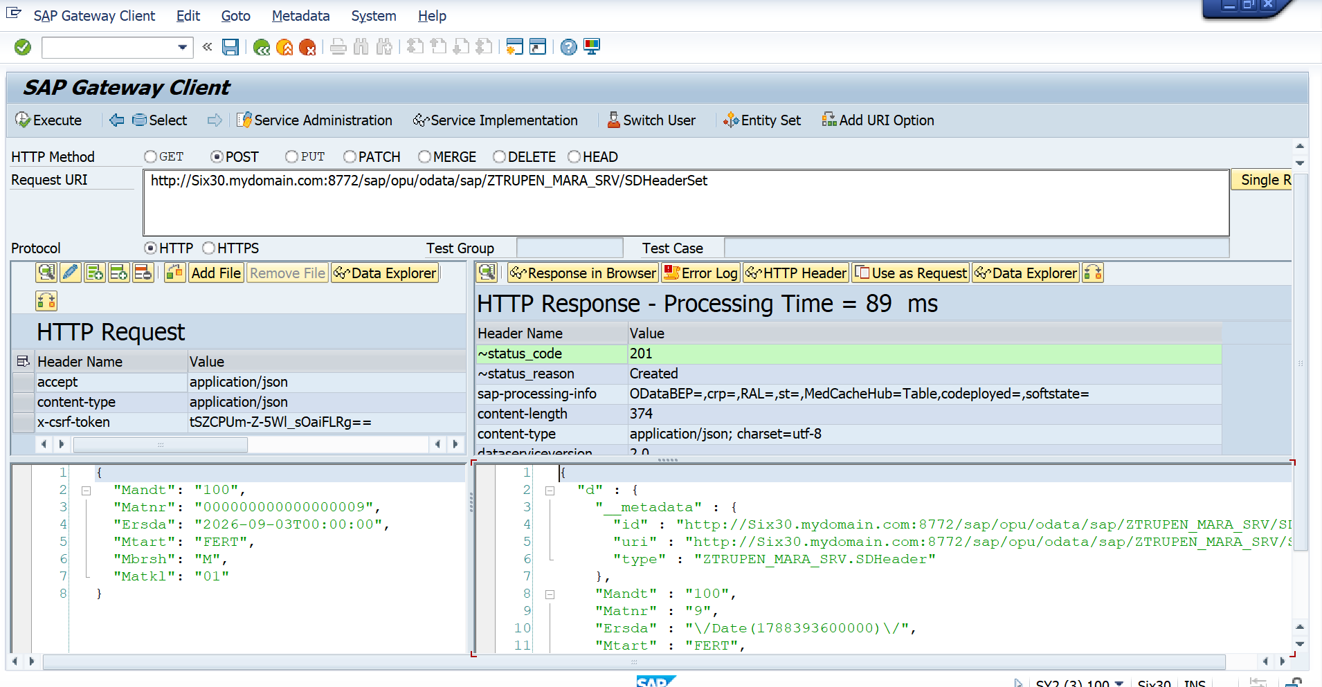

PUT:
http://Six30.mydomain.com:8772/sap/opu/odata/sap/ZTRUPEN_MARA_SRV/SDHeaderSet(Mandt='100',Matnr='000000000000000009')
{
"Mandt": "100",
"Matnr": "000000000000000009",
"Ersda": "2026-09-03T00:00:00",
"Mtart": "FERT",
"Mbrsh": "C",
"Matkl": "01"
}

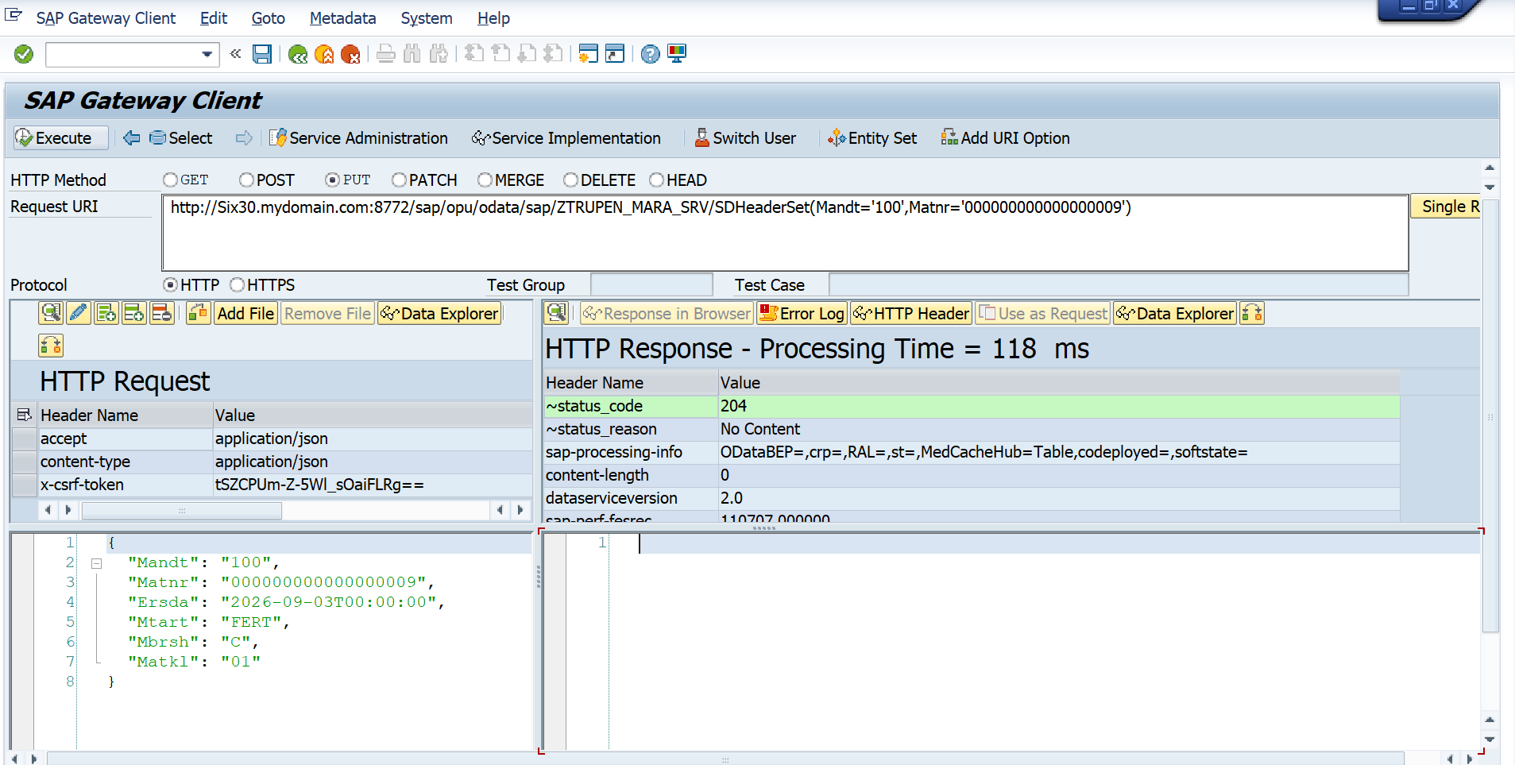

DELETE:
http://Six30.mydomain.com:8772/sap/opu/odata/sap/ZTRUPEN_MARA_SRV/SDHeaderSet(Mandt='100',Matnr='000000000000000009')

